Министерство науки и высшего образования Российской Федерации

Федеральное государственное автономное образовательное учреждение высшего образования

«Национальный исследовательский университет ИТМО»

*Факультет программной инженерии и компьютерной техники*

**Курсовая работа**

по дисциплине

«Дискретная математика»

Вариант №94

Выполнил:

Студент группы P3113

Султанов А.Р.

Преподаватель:

Поляков В.И.

г. Санкт-Петербург

2022г.

# Оглавление

**Оглавление** **2**

**Часть 1** **3**

# Часть 1

Вариант: 94

Условия, при которых f=1: $(x_{5}x_{4}+x_{3}x_{2}x_{1})=1, 5, 6, 7, 8$

Условия, при которых f=d: $(x_{5}x_{4}+x_{3}x_{2}x_{1})=3$

| N | $x_{1}x_{2}x_{3}x_{4}x_{5}$ | $x_{5}x_{4}$ | $(x_{5}x_{4})_{10}$ | $x_{3}x_{2}x_{1}$ | ${(x}_{3}x_{2}x_{1})_{10}$ | $+$ | $f$ |
| --- | --- | --- | --- | --- | --- | --- | --- |
| 0 | 0 0 0 0 0 | 0 0 | 0 | 0 0 0 | 0 | 0 | 0 |
| 1 | 0 0 0 0 1 | 1 0 | 2 | 0 0 0 | 0 | 2 | 0 |
| 2 | 0 0 0 1 0 | 0 1 | 1 | 0 0 0 | 0 | 1 | 1 |
| 3 | 0 0 0 1 1 | 1 1 | 3 | 0 0 0 | 0 | 3 | D |
| 4 | 0 0 1 0 0 | 0 0 | 0 | 1 0 0 | 4 | 4 | 0 |
| 5 | 0 0 1 0 1 | 1 0 | 2 | 1 0 0 | 4 | 6 | 1 |
| 6 | 0 0 1 1 0 | 0 1 | 1 | 1 0 0 | 4 | 5 | 1 |
| 7 | 0 0 1 1 1 | 1 1 | 3 | 1 0 0 | 4 | 7 | 1 |
| 8 | 0 1 0 0 0 | 0 0 | 0 | 0 1 0 | 2 | 2 | 0 |
| 9 | 0 1 0 0 1 | 1 0 | 2 | 0 1 0 | 2 | 4 | 0 |
| 10 | 0 1 0 1 0 | 0 1 | 1 | 0 1 0 | 2 | 3 | D |
| 11 | 0 1 0 1 1 | 1 1 | 3 | 0 1 0 | 2 | 5 | 1 |
| 12 | 0 1 1 0 0 | 0 0 | 0 | 1 1 0 | 6 | 6 | 1 |
| 13 | 0 1 1 0 1 | 1 0 | 2 | 1 1 0 | 6 | 8 | 1 |
| 14 | 0 1 1 1 0 | 0 1 | 1 | 1 1 0 | 6 | 7 | 1 |
| 15 | 0 1 1 1 1 | 1 1 | 3 | 1 1 0 | 6 | 9 | 0 |
| 16 | 1 0 0 0 0 | 0 0 | 0 | 0 0 1 | 1 | 1 | 1 |
| 17 | 1 0 0 0 1 | 1 0 | 2 | 0 0 1 | 1 | 3 | D |
| 18 | 1 0 0 1 0 | 0 1 | 1 | 0 0 1 | 1 | 2 | 0 |
| 19 | 1 0 0 1 1 | 1 1 | 3 | 0 0 1 | 1 | 4 | 0 |
| 20 | 1 0 1 0 0 | 0 0 | 0 | 1 0 1 | 5 | 5 | 1 |
| 21 | 1 0 1 0 1 | 1 0 | 2 | 1 0 1 | 5 | 7 | 1 |
| 22 | 1 0 1 1 0 | 0 1 | 1 | 1 0 1 | 5 | 6 | 1 |
| 23 | 1 0 1 1 1 | 1 1 | 3 | 1 0 1 | 5 | 8 | 1 |
| 24 | 1 1 0 0 0 | 0 0 | 0 | 0 1 1 | 3 | 3 | D |
| 25 | 1 1 0 0 1 | 1 0 | 2 | 0 1 1 | 3 | 5 | 1 |
| 26 | 1 1 0 1 0 | 0 1 | 1 | 0 1 1 | 3 | 4 | 0 |
| 27 | 1 1 0 1 1 | 1 1 | 3 | 0 1 1 | 3 | 6 | 1 |
| 28 | 1 1 1 0 0 | 0 0 | 0 | 1 1 1 | 7 | 7 | 1 |
| 29 | 1 1 1 0 1 | 1 0 | 2 | 1 1 1 | 7 | 9 | 0 |
| 30 | 1 1 1 1 0 | 0 1 | 1 | 1 1 1 | 7 | 8 | 1 |
| 31 | 1 1 1 1 1 | 1 1 | 3 | 1 1 1 | 7 | 10 | 0 |

КДНФ: $\underline{x_{1}} \underline{x_{2}} \underline{x_{3}} x_{4} \underline{x_{5}}∨\underline{x_{1}} \underline{x_{2}} x_{3} \underline{x_{4}} x_{5}∨\underline{x_{1}} \underline{x_{2}} x_{3} x_{4} \underline{x_{5}}∨\underline{x_{1}} \underline{x_{2}} x_{3} x_{4} x_{5}∨\underline{x_{1}} x_{2} \underline{x_{3}} x_{4} x_{5}∨$

$∨\underline{x_{1}} x_{2} x_{3} \underline{x_{4}} \underline{x_{5}}∨\underline{x_{1}} x_{2} x_{3} \underline{x_{4}} x_{5}∨\underline{x_{1}} x_{2} x_{3} x_{4} \underline{x_{5}}∨x_{1} \underline{x_{2}} \underline{x_{3}} \underline{x_{4}} \underline{x_{5}}∨x_{1} \underline{x_{2}} x_{3} \underline{x_{4}} \underline{x_{5}}∨$

$∨x_{1} \underline{x_{2}} x_{3} \underline{x_{4}} x_{5}∨x_{1} \underline{x_{2}} x_{3} x_{4} \underline{x_{5}}∨x_{1} \underline{x_{2}} x_{3} x_{4} x_{5}∨x_{1} x_{2} \underline{x_{3}} \underline{x_{4}} x_{5}∨x_{1} x_{2} \underline{x_{3}} x_{4} x_{5}∨$

$∨x_{1} x_{2} x_{3} \underline{x_{4}} \underline{x_{5}}∨x_{1} x_{2} x_{3} x_{4} \underline{x_{5}}$

ККНФ:

|  |  |  |  |  |  |  |  |  |  |  |  |
| --- | --- | --- | --- | --- | --- | --- | --- | --- | --- | --- | --- |
| 1 | 0 0 0 1 0 | v | 1 | 0 0 0 1 X | 1 - 2 | v | 1 | 0 0 X 1 X | 1 - 9, 2 - 4 | 1 | 0 X 1 0 1 |
| 2 | 0 0 0 1 1 | v | 2 | 0 0 X 1 0 | 1 - 4 | v | 2 | 0 X 0 1 X | 1 - 13, 3 - 5 | 2 | X 1 0 1 1 |
| 3 | 0 0 1 0 1 | v | 3 | 0 X 0 1 0 | 1 - 6 | v | 3 | 0 X X 1 0 | 2 - 14, 3 - 10 | 3 | 0 1 1 0 X |
| 4 | 0 0 1 1 0 | v | 4 | 0 0 X 1 1 | 2 - 5 | v | 4 | X 0 1 X 1 | 6 - 28, 8 - 12 | 4 | 1 1 0 X 1 |
| 5 | 0 0 1 1 1 | v | 5 | 0 X 0 1 1 | 2 - 7 | v | 5 | X 0 1 1 X | 9 - 29, 11 - 12 | 5 | 0 0 X 1 X |
| 6 | 0 1 0 1 0 | v | 6 | 0 0 1 X 1 | 3 - 5 | v | 6 | X X 1 1 0 | 10 - 30, 11 - 19 | 6 | 0 X 0 1 X |
| 7 | 0 1 0 1 1 | v | **7** | **0 X 1 0 1** | 3 - 9 |  | 7 | X 1 1 X 0 | 17 - 34, 18 - 19 | 7 | 0 X X 1 0 |
| 8 | 0 1 1 0 0 | v | 8 | X 0 1 0 1 | 3 - 14 | v | 8 | 1 0 X 0 X | 20 - 25, 21 - 23 | 8 | X 0 1 X 1 |
| 9 | 0 1 1 0 1 | v | 9 | 0 0 1 1 X | 4 - 5 | v | 9 | 1 X 0 0 X | 20 - 31, 22 - 24 | 9 | X 0 1 1 X |
| 10 | 0 1 1 1 0 | v | 10 | 0 X 1 1 0 | 4 - 10 | v | 10 | 1 X X 0 0 | 21 - 32, 22 - 27 | 10 | X X 1 1 0 |
| 11 | 1 0 0 0 0 | v | 11 | X 0 1 1 0 | 4 - 15 | v | 11 | 1 0 1 X X | 25 - 29, 26 - 28 | 11 | X 1 1 X 0 |
| 12 | 1 0 0 0 1 | v | 12 | X 0 1 1 1 | 5 - 16 | v | 12 | 1 X 1 X 0 | 26 - 34, 27 - 30 | 12 | 1 0 X 0 X |
| 13 | 1 0 1 0 0 | v | 13 | 0 1 0 1 X | 6 - 7 | v |  |  |  | 13 | 1 X 0 0 X |
| 14 | 1 0 1 0 1 | v | 14 | 0 1 X 1 0 | 6 - 10 | v |  |  |  | 14 | 1 X X 0 0 |
| 15 | 1 0 1 1 0 | v | **15** | **X 1 0 1 1** | 7 - 19 |  |  |  |  | 15 | 1 0 1 X X |
| 16 | 1 0 1 1 1 | v | **16** | **0 1 1 0 X** | 8 - 9 |  |  |  |  | 16 | 1 X 1 X 0 |
| 17 | 1 1 0 0 0 | v | 17 | 0 1 1 X 0 | 8 - 10 | v |  |  |  |  |  |
| 18 | 1 1 0 0 1 | v | 18 | X 1 1 0 0 | 8 - 20 | v |  |  |  |  |  |
| 19 | 1 1 0 1 1 | v | 19 | X 1 1 1 0 | 10 - 21 | v |  |  |  |  |  |
| 20 | 1 1 1 0 0 | v | 20 | 1 0 0 0 X | 11 - 12 | v |  |  |  |  |  |
| 21 | 1 1 1 1 0 | v | 21 | 1 0 X 0 0 | 11 - 13 | v |  |  |  |  |  |
|  |  |  | 22 | 1 X 0 0 0 | 11 - 17 | v |  |  |  |  |  |
|  |  |  | 23 | 1 0 X 0 1 | 12 - 14 | v |  |  |  |  |  |
|  |  |  | 24 | 1 X 0 0 1 | 12 - 18 | v |  |  |  |  |  |
|  |  |  | 25 | 1 0 1 0 X | 13 - 14 | v |  |  |  |  |  |
|  |  |  | 26 | 1 0 1 X 0 | 13 - 15 | v |  |  |  |  |  |
|  |  |  | 27 | 1 X 1 0 0 | 13 - 20 | v |  |  |  |  |  |
|  |  |  | 28 | 1 0 1 X 1 | 14 - 16 | v |  |  |  |  |  |
|  |  |  | 29 | 1 0 1 1 X | 15 - 16 | v |  |  |  |  |  |
|  |  |  | 30 | 1 X 1 1 0 | 15 - 21 | v |  |  |  |  |  |
|  |  |  | 31 | 1 1 0 0 X | 17 - 18 | v |  |  |  |  |  |
|  |  |  | 32 | 1 1 X 0 0 | 17 - 20 | v |  |  |  |  |  |
|  |  |  | **33** | **1 1 0 X 1** | 18 - 19 |  |  |  |  |  |  |
|  |  |  | 34 | 1 1 1 X 0 | 20 - 21 | v |  |  |  |  |  |

**Составление импликантной таблицы**

| Простые импликанты (максимальные кубы) | | 0-кубы | | | | | | | | | | | | | | | | |
| --- | --- | --- | --- | --- | --- | --- | --- | --- | --- | --- | --- | --- | --- | --- | --- | --- | --- | --- |
| 0 0 0 1 0 | 0 0 1 0 1 | 0 0 1 1 0 | 0 0 1 1 1 | 0 1 0 1 1 | 0 1 1 0 0 | 0 1 1 0 1 | 0 1 1 1 0 | 1 0 0 0 0 | 1 0 1 0 0 | 1 0 1 0 1 | 1 0 1 1 0 | 1 0 1 1 1 | 1 1 0 0 1 | 1 1 0 1 1 | 1 1 1 0 0 | 1 1 1 1 0 |
| a | b | c | d | e | f | g | h | i | j | k | l | m | n | o | p | r |
| A | 0 X 1 0 1 |  | * |  |  |  |  | * |  |  |  |  |  |  |  |  |  |  |
| B | X 1 0 1 1 |  |  |  |  | * |  |  |  |  |  |  |  |  |  | * |  |  |
| C | 0 1 1 0 X |  |  |  |  |  | * | * |  |  |  |  |  |  |  |  |  |  |
| D | 1 1 0 X 1 |  |  |  |  |  |  |  |  |  |  |  |  |  | * | * |  |  |
| E | 0 0 X 1 X | * |  | * | * |  |  |  |  |  |  |  |  |  |  |  |  |  |
| F | 0 X 0 1 X | * |  |  |  | * |  |  |  |  |  |  |  |  |  |  |  |  |
| G | 0 X X 1 0 | * |  | * |  |  |  |  | * |  |  |  |  |  |  |  |  |  |
| H | X 0 1 X 1 |  | * |  | * |  |  |  |  |  |  | * |  | * |  |  |  |  |
| I | X 0 1 1 X |  |  | * | * |  |  |  |  |  |  |  | * | * |  |  |  |  |
| J | X X 1 1 0 |  |  | * |  |  |  |  | * |  |  |  | * |  |  |  |  | * |
| K | X 1 1 X 0 |  |  |  |  |  | * |  | * |  |  |  |  |  |  |  | * | * |
| L | 1 0 X 0 X |  |  |  |  |  |  |  |  | * | * | * |  |  |  |  |  |  |
| M | 1 X 0 0 X |  |  |  |  |  |  |  |  | * |  |  |  |  | * |  |  |  |
| N | 1 X X 0 0 |  |  |  |  |  |  |  |  | * | * |  |  |  |  |  | * |  |
| O | 1 0 1 X X |  |  |  |  |  |  |  |  |  | * | * | * | * |  |  |  |  |
| P | 1 X 1 X 0 |  |  |  |  |  |  |  |  |  | * |  | * |  |  |  | * | * |

**Метод Петрика**

$f=(E∨F∨G)(A∨H)(E∨G∨I∨J)(E∨H∨I)(B∨F)(C∨K)(A∨C)$

$(G∨J∨K)(L∨M∨N)(L∨N∨O∨P)(H∨L∨O)(I∨J∨O∨P)(H∨I∨O)$

$(D∨M)(B∨D)(K∨N∨P)(J∨K∨P)=$

$=(A∨B∨E∨K∨M∨O)(A∨D∨F∨I∨K∨L)$

$(B∨C∨D∨G∨H∨J∨N)(B∨C∨D∨G∨H∨K∨N∨O) ...$

(для удобства опущено большое количество термов, приведены несколько)

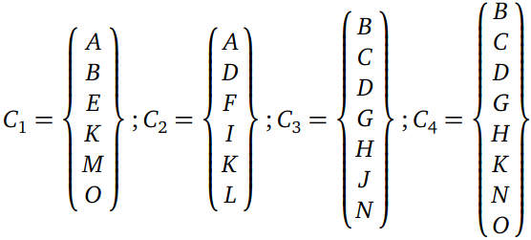

$S_{1}^{a}=20; S_{1}^{b}=26$ $S_{2}^{a}=20; S_{2}^{b}=26$ $S_{3}^{a}=24; S_{3}^{b}=31$

$S_{4}^{a}=27; S_{4}^{b}=35$

Минимальное покрытие функции - $C_{1}$

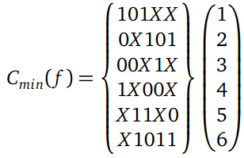

$S^{a}=20, S^{b}=20+6=26$

$f=(x_{1}¬x_{2}x_{3})∨(¬x_{1}x_{3}¬x_{4}x_{5})∨(¬x_{1}¬x_{2}x_{4})∨(x_{1}¬x_{3}¬x_{4})∨(x_{2}x_{3}¬x_{5})∨$

$∨(x_{2}{¬x}_{3}x_{4}x_{5})$

**Минимизация булевой функции на картах Карно**

**Определение МДНФ**

$x_{1}=0$:

| **x2x3/x4x5** | **00** | **01** | **11** | **10** |
| --- | --- | --- | --- | --- |
| **00** | 0 | 0 | **d** | **1** |
| **01** | 0 | **1** | **1** | **1** |
| **11** | **1** | **1** | 0 | **1** |
| **10** | 0 | 0 | **1** | **d** |

$x_{1}=1$:

| **x2x3/x4x5** | **00** | **01** | **11** | **10** |
| --- | --- | --- | --- | --- |
| **00** | **1** | **d** | 0 | 0 |
| **01** | **1** | **1** | **1** | **1** |
| **11** | **1** | 0 | 0 | **1** |
| **10** | **d** | **1** | **1** | 0 |



$S^{a}=20, S^{b}=20+6=26$

$f=(x_{1}¬x_{2}x_{3})∨(¬x_{1}x_{3}¬x_{4}x_{5})∨(¬x_{1}¬x_{2}x_{4})∨(x_{1}¬x_{3}¬x_{4})∨(x_{2}x_{3}¬x_{5})∨$

$∨(x_{2}{¬x}_{3}x_{4}x_{5})$

**Определение МКНФ**

$x_{1}=0$:

| x2x3/x4x5 | **00** | **01** | **11** | **10** |
| --- | --- | --- | --- | --- |
| **00** | **0** | **0** | **d** | 1 |
| **01** | **0** | 1 | 1 | 1 |
| **11** | 1 | 1 | **0** | 1 |
| **10** | **0** | **0** | 1 | **d** |

$x_{1}=1$:

| x2x3/x4x5 | **00** | **01** | **11** | **10** |
| --- | --- | --- | --- | --- |
| **00** | 1 | **d** | **0** | **0** |
| **01** | 1 | 1 | 1 | 1 |
| **11** | 1 | **0** | **0** | 1 |
| **10** | **d** | 1 | 1 | **0** |

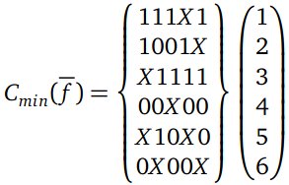

$S^{a}=22, S^{b}=22+6=28$

$f=(¬x_{1}∨¬x_{2}∨¬x_{3}∨¬x_{5})({¬x}_{1}∨x_{2}∨x_{3}∨¬x_{4})({¬x}_{2}∨¬x_{3}∨¬x_{4}∨¬x_{5})$

$(x_{1}∨x_{2}∨x_{4}∨x_{5})({¬x}_{2}∨x_{3}∨x_{5})(x_{1}∨x_{3}∨x_{4})$

**Преобразование минимальных форм булевой функции**

**Факторное преобразование для МДНФ**

$f=(x_{1}¬x_{2}x_{3})∨(¬x_{1}x_{3}¬x_{4}x_{5})∨(¬x_{1}¬x_{2}x_{4})∨(x_{1}¬x_{3}¬x_{4})∨(x_{2}x_{3}¬x_{5})∨$

$∨(x_{2}{¬x}_{3}x_{4}x_{5})$

$S^{Q}=26$

$=x_{3}(x_{1}¬x_{2}∨¬x_{1}¬x_{4}x_{5}∨x_{2}¬x_{5})∨x_{4}(¬x_{1}¬x_{2}∨x_{2}{¬x}_{3}x_{5}){∨x}_{1}¬x_{3}¬x_{4}$ $S^{Q}=27$

Различные преобразования методом факторизации и декомпозиции также не принесли успеха.

**Факторное преобразование для МКНФ**

$f=(¬x_{1}∨¬x_{2}∨¬x_{3}∨¬x_{5})({¬x}_{1}∨x_{2}∨x_{3}∨¬x_{4})({¬x}_{2}∨¬x_{3}∨¬x_{4}∨¬x_{5})$

$(x_{1}∨x_{2}∨x_{4}∨x_{5})({¬x}_{2}∨x_{3}∨x_{5})(x_{1}∨x_{3}∨x_{4})$

$S^{Q}=28$

$=({¬x}_{2}∨¬x_{3}∨{¬x}_{5}∨¬x_{1}{¬x}_{4})(x_{3}∨({¬x}_{1}∨x_{2}∨{¬x}_{4})({¬x}_{2}∨x_{5})(x_{1}∨x_{4}))$

$(x_{1}∨x_{2}∨x_{4}∨x_{5})$

$S^{Q}=25$

$φ=x_{1}∨x_{4}$

$=({¬x}_{2}∨¬x_{3}∨{¬x}_{5}∨¬φ)(x_{3}∨φ({¬x}_{1}∨x_{2}∨{¬x}_{4})({¬x}_{2}∨x_{5}))$

$(φ∨x_{2}∨x_{5})$

$S^{Q}=23, S_{Q}^{f}=21, S_{Q}^{φ}=2$

**Булевый базис с парафазными входами**

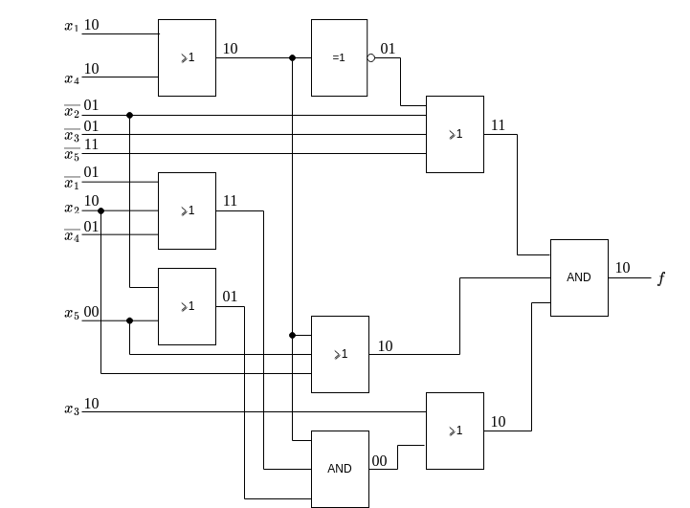

$T=4t, S^{Q}=23 (S_{Q}^{f}=21, S_{Q}^{φ}=2)$

$f(11110)=1$

$f(00000)=0$

**Булевый базис с однофазными входами**

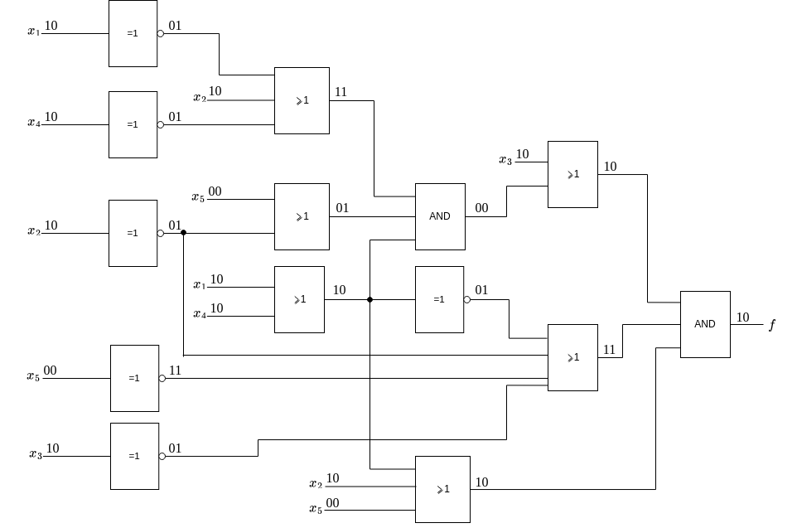

$T=5t,S^{Q}=28 (S_{Q}^{f}=26, S_{Q}^{φ}=2)$

$f(11110)=1$

$f(00000)=0$

**Универсальный базис И-НЕ**

$f=(x_{1}¬x_{2}x_{3})∨(¬x_{1}x_{3}¬x_{4}x_{5})∨(¬x_{1}¬x_{2}x_{4})∨(x_{1}¬x_{3}¬x_{4})∨(x_{2}x_{3}¬x_{5})∨$

$∨(x_{2}{¬x}_{3}x_{4}x_{5})$ $=¬(¬(x_{1}¬x_{2}x_{3})¬(¬x_{1}x_{3}¬x_{4}x_{5})¬(¬x_{1}¬x_{2}x_{4})¬(x_{1}¬x_{3}¬x_{4})¬(x_{2}x_{3}¬x_{5})¬(x_{2}{¬x}_{3}x_{4}x_{5}))$

$=¬(x_{1}¬x_{2}x_{3})|¬(¬x_{1}x_{3}¬x_{4}x_{5})|¬(¬x_{1}¬x_{2}x_{4})|¬(x_{1}¬x_{3}¬x_{4})|¬(x_{2}x_{3}¬x_{5})|¬(x_{2}{¬x}_{3}x_{4}x_{5})$

$=(x_{1}|¬x_{2}|x_{3})|(¬x_{1}|x_{3}|¬x_{4}|x_{5})|(¬x_{1}|¬x_{2}|x_{4})|(x_{1}|¬x_{3}|¬x_{4})|(x_{2}|x_{3}|¬x_{5})|(x_{2}|{¬x}_{3}|x_{4}|x_{5})$

$S^{Q}=26$

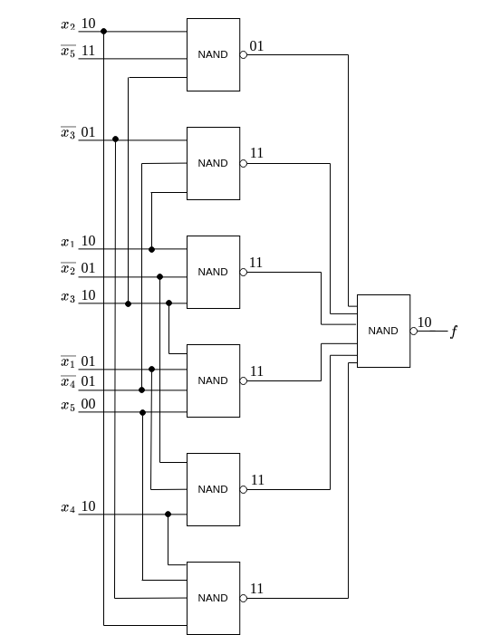

$T=2t, S^{Q}=26$

$f(11110)=1$

$f(00000)=0$